Adventist University of Central Africa

STANDARDIZED ORDERING AND TRANSPORT PLANNING PRACTICE SYSTEM (STOPPS)

Case study: LINFOX RWANDA LTD

A research project presented in partial fulfillment of the requirement for the degree BACHELOR OF SCIENCE IN INFORMATION TECHNOLOGY

Major in

SOFTWARE ENGINEERING

By

IHAME Gilbert

November, 2022

# ABSTRACT

Research Project for the bachelor’s degree in Information Technology

Emphasis in Software Engineering

**TITLE:** Standardized Ordering and Transport Planning Practice System

**Case Study**: Linfox Rwanda

**Name of the researcher:** IHAME Gilbert

**Name of faculty Advisor:** Mr. NIYODUSENGA Jean Pierre

**Date Completed:** December 2022

The **Standardized Ordering and Transport Planning Practice System (STOPPS)** was developed primarily to assist people in placing an order on the property to aid in the construction of a home and make it easy to find transport of those products. Even those who already own property can add it to the platform so that anyone who does not already own it can view it and place an order if they so choose. Customers will also have the option of reporting a specific property if they believe the service is unfair.

The owner of the product will have the ability to register it, fill out all the necessary information for it to be provided, view and accept or reject any requests from customers, and register it.

Requests for the creation of customer or product owner accounts can be approved or rejected by a system administrator. The product owner and customers can view all System Admin notifications by receiving a notification that System Admin has sent. System administrators can monitor customer reports and decide whether to accept or reject the reported product.

# DECLARATION

I, Gilbert IHAME, hereby declare that, except where references are made, this is my original work and that it has never been submitted for an award to this or any other university or institution. Every effort has been made to ensure the accuracy of the information presented in this book.

Signature: ........………………….

Name: IHAME Gilbert

Date: November 2022

# APPROVAL

I, NIYODUSENGA Jean Pierrehereby validate that this project report has been overseen by myself and presented with my

acceptance.

Signature:

Date: ……/……………/…………

# DEDICATION

With great pleasure, I dedicate this Research Project

To my lovely parents,

To my lovely brothers and sisters,

To my relatives and all my colleagues at AUCA.

# TABLE OF CONTENTS

DECLARATION i

APPROVAL ii

DEDICATION iii

PROJECT ABSTRACT iv

TABLE OF CONTENTS v

TABLE OF FIGURES viii

LIST OF ABBREVIATION x

ACKNOWLEDGEMENT xi

CHAPTER 1: 1

GENERAL INTRODUCTION 1

Background of the Study 1

Statement of the Problem 2

Choice and Motivation in the Study 3

Objectives of the Study 3

General Objective 3

Specific Objectives 3

Challenges 4

Scope of the Project 4

Methodology and Techniques Used in the Study 4

Observation 5

Interview 5

Documentations 6

Research Questions 6

Expected Results 6

Organization of Report 7

CHAPTER 2: 8

ANALYSIS OF THE EXISTING SYSTEM 8

Introduction 8

Background of Linfox Rwanda 8

Description of Current System Environment 9

Mission 9

Vision 9

Modeling Current System 10

Problems of Existing System 11

Proposed Solutions 11

Functional Requirements 11

Non-Functional Requirements 12

CHAPTER 3 14

REQUIREMENTS ANALYSIS AND DESIGN OF THE NEW SYSTEM 14

Introduction 14

System analysis: 14

System design: 14

Analysis and Design Methodology 15

Object Oriented Methodology (OOM) 15

Unified Modelling Language (UML) 16

UML Models 16

Analysis of the new system 17

Requirement Analysis 17

Design of the New System – Diagrams 17

Use-Case Diagrams 17

Use case description 18

Class Diagrams 23

System’s class diagram 27

Sequence Diagram 28

Create Account sequence diagram 30

Login sequence diagram 30

Place Order sequence diagram 31

Product Owner Publish product sequence diagram 31

Admin (Linfox) register cargo sequence diagram 32

Activity Diagram 32

Customer Order 34

Database Diagram 34

System’s database diagram 35

System Architecture Design 37

CHAPTER 4: 38

IMPLEMENTATION OF THE NEW SYSTEM 38

Introduction 38

Browser compatibility 38

Tools and Technology Used 38

Presentation of the New System 40

CHAPTER 5: 53

CONCLUSION AND RECOMMENDATIONS 53

General conclusions 53

Recommendations 54

REFERENCES 55

Books 55

Websites 55

APPENDICES 56

# TABLE OF FIGURES

Figure 1:Current system 9

Figure 2:Use Case Diagram 15

Figure 3: System's Class diagram 21

Figure 4:Create account sequence diagram 23

Figure 5:Login sequence diagram 23

Figure 6:Place order sequence diagram 24

Figure 7:Product Owner Publish product sequence diagram 24

Figure 8:Admin (Linfox) register cargo sequence diagram 25

Figure 9: Customer Order 27

Figure 10:Database schema 28

Figure 11:System architecture 29

Figure 12: My home page 33

Figure 13: Log in as admin 34

Figure 14:Admin home page 34

Figure 15:Admin change status completely 35

Figure 16:home admin 35

Figure 17: All users 36

Figure 18:Check out 36

Figure 19: Profile Log in authorization 37

Figure 20: Product Owner home 38

Figure 21: Profile 39

Figure 22: Manager users 40

# LIST OF TABLES

Table 1:Create account 19

Table 2:Login 20

Table 3:Record a product 20

Table 4:Client Order Product 21

Table 5:Payment for a particular order and transport 22

Table 6:change Order status 23

Table 7:Symbols used in sequence diagram 29

Table 8:Browser compatibility 38

Table 9:Tools and Technology Used 38

# LIST OF ABBREVIATION

**AUCA** - Adventist University of Central Africa

CD’s - Compact Disc

CASE - Computer-Assisted Software Engineering

CSS - Cascading Style Sheet

DBMS - Data Base Management System

JS - Java Script

HTML - Hypertext Markup Language

HTTP - Hyper Text Transfer Protocol

IT - Information Technology

MYSQL - My Structured Query Language

OOA - Object Oriented Analysis

OOD - Object Oriented Design

OOM - Object Oriented Methodology

OOP - Object Oriented Programming

OMG - Object Management Group

OOSE - Object-oriented Software Engineering

PDF - Portable Document Format

PK - Primary key

FK - Foreign Key

UML - Unified Modeling Language

GUI - Graphic User Interface

UML - Unified Modelling Language

SDP - Software Development Process

OOAD  **-** Object Oriented Analysis and Design

VS **-** Visual studio

DB **-** Database

# ACKNOWLEDGEMENT

I am extremely grateful to my supervisor, Mr. NIYODUSENGA Jean Pierre, who guided me in the completion of this work, especially for his valuable advice, professional assistance, guidance, and ideas.

I also thank the Adventist University of Central Africa teachers for providing me with the best educational opportunities. I would like to thank the administration of Adventist University of Central Africa as well as the department of Information Technology staff.

My parents deserve special recognition for their assistance in completing my studies in one way or another during the academic period, especially for their valuable advice and prayers.

Because no one is truly self-made, I would like to express my gratitude to my colleagues at AUCA, especially IHIRWE Jean Felicien, for their encouragement and invaluable assistance.

IHAMEGilbert

# CHAPTER 1

# GENERAL INTRODUCTION

**Introduction**

This system refers to solving this problem and trying to help those people to get older on that property to help them in construction of a house and even some who have that property can add that property on that platform and anyone who can’t see it and order it if they wish. Due to the large population and the nature of our everyday lives, many people are very busy, which is why I am looking forward to implementing this system.

Nowadays, many people get jobs in different fields, but they are supposed to know or to have news and updates on different platforms. In the domain of transportation of goods, sometimes people want to build a house or transport anything, but they do not have any idea where they have to go to buy those properties and transport them from one place to another.

## Background of the Study

Rwanda is the most developing country in the world in many areas, such as technology, agriculture, etc. In every activity, our government institutions, private sectors strive to improve service delivery as it is one of the core pillars toward a sustainable economy. In most cases, information technology (IT) plays a major role in digitalizing how businesses, governments, non-government, or private companies work (Arias, 2017).

In terms of online business, which involves product ordering and transportation, Rwanda has done a very good job of allowing citizens to order and receive their orders at home. These services are more well represented in domains such as food delivery, groceries, clothing businesses, and electronic devices. For instance, food delivery applications such as VubaVuba, RushFood, etc., can allow users to order food from home. In other areas, such as online shopping, we have applications like Murukali, DMM-HeHe, Pack&Pick. In addition to that, companies such as Olado are more focused on allowing the ordering and transport of electronic devices.

However, the existing system only focuses on allowing the ordering of products that are easy to transport, which makes it more convenient for businesses. In addition to that, the existing systems rely on their own. They have limited transportation facilities, which makes it challenging in the event a client needs a product beyond their transportation capacities.

Linfox Transportation is an international logistics company that helps people with their transportation needs. They work with some of the world’s largest and most successful organizations, delivering food, resources, and medicine across road and rail from an extensive network of warehouses and distribution centers.

In our proposed project, we plan to use the Linfox Transport experience to solve such issues as those present in the Rwanda market in terms of heavy product ordering and transportation by providing a framework able to provide standardized ordering and transportation capabilities, focusing more on heavy transported products.

## Statement of the Problem

Life of delivery company is to connect seller and buyer where user can buy goods online from his favorite restaurant, markets or liquor store and get order at his place.

They are some problems their face with:

* Late delivery
* Lack of product customer want
* Intermediate between product owner, transport, and client
* Reduce phone call between riders and office.

An increase in traffic and inflation has currently been observed, yet people need goods and must move from one place to another. It’s been noticed that due to the increase in traffic and fare costs, people have been spending and wasting time and money every time they want to connect from one place to another. Due to these facts, there has been a decrease in sales as well as cash collection. Also, the Rwandan population can order products they want online without having to go anywhere. Lack of timely information on products in markets, transport and trusted delivery services has contributed to some of the issues. The current system or way users go looking for transport and deliveries should be done through the platform I’m developing, and this will address the issues. There is the security and safety of goods in transportation. The current way is to limit the user to ordering anytime they want and transporting their products.

## Choice and Motivation in the Study

As a graduate student at Adventist University of Central Africa (AUCA), I am very happy to develop a system that can serve a huge number of citizens and solve their problems and obstacles that they encounter in ordering products and transporting those products.

For academic reasons, the success of my research will fulfill the requirements of students to get a bachelor's degree from Adventist University of Central Africa, as it is required. The development of this system will also help me improve my skills in programming and ability to work on different projects as well as in our Rwandan society to increase the level of technology, as Rwanda has "smart KIGALI," which will help me in normal life beyond studies.

## Objectives of the Study

### General Objective

The general objective of **Standardized Ordering and Transport the Planning Practice System (STOPPS)** is to develop web applications that will allow people to publish, order, and transport their heavy construction properties or any other things to be sold over the internet on their telephone/tablets/computer etc.…

### Specific Objectives

There are some specific objectives of the system that I mentioned below:

* First, I must collect the requirements.
* The second is to design my project well so that it can be easy to understand.
* The third is to code my project using DJANGO framework technology.
* Four The fourth test is to test that software so that it can be trusted. The fifth is to deploy the software so that it can be accessible by anyone.
* Finally, to do maintenance when it is required.

Listed below are specific objectives:

* It will show the activity that has a positive effect on the local population.
* It will show the activity that will create more jobs for the local population.
* It will show the activity which will create opportunities for income generation for the population /Transport Company.
* It will show the activities that have an impact on poverty reduction.
* It will increase the use of technology in buy and sell activity and transport.

## Challenges

Developing a computerized system is not a simple task, even for a small organization. The process demands that you be very attentive and have sufficient time and experience to meet all customer needs. The biggest challenge that may be faced in developing the web application is the lack of sufficient experience in developing applications.

For collecting data, it requires some methods such as interviews and observations, and here the research project may not meet its objectives when an interviewee provides incomplete or wrong information. Also, if observation is not done as expected, the conduction of research cannot be good.

## Scope of the Project

Standardized Ordering and Transport the Planning Practice System (STOPPS) is a web-based application whereby research about it was conducted within Rwandans to solve the current problems of the existing system.

The project was developed for the purpose of solving ordering and transport problems of heavy products that most of the clients met with a particular company that sold those products.

## Methodology and Techniques Used in the Study

Research methodology describes how to conduct research. Many facts are involved in conducting research. To highly understand and figure out well what is really the problem, what is the understanding of the people you are going to solve their problem. To reach to that we us different method to collect data and information which are interview, questionnaire, observation and on internet by doing some search.

The followings are techniques used in the analysis of the existing system.

### Observation

*Observation* is the methodical collecting of data. In natural settings or scenarios, researchers employ all their senses to investigate.

Observation as a method of data collection was used. In this aspect, the researcher used an unstructured observation in order to identify physical social problems of Transport and Ordering such as the struggle to get someone who has a product and get transport at time you want it and you know is a waste of time as well. After gathering all the requirements from the stakeholders using all the above-mentioned data collection techniques, the gathered requirements were analyzed and validated to review stakeholder’s information which was not always 100% accurate.

Observing all those issues, I came up with the idea of implementing a Standardized Ordering and Transport Planning Practice System web application where admin can see daily customer prediction.

### Interview

Interview is defined as a systematic conversation between an investigator (interviewer) and an informant (interviewee), initiated for obtaining information to a relevant specific study. To understand deeply the problem domain, interview plan as a data collection technique also helped to achieve the meaning of this project.

The researcher used interview techniques while collecting data about Linfox Transport for example shavers, manager of Linfox Transport and their customers were interviewed. This involved an interviewer and an interviewee (respondent).

This technique helped the researcher to obtain accurate information since there was direct interaction with the respondent and he or she was provided with relevant information. The collected data was inspected, transformed, and modeled with the goal of highlighting useful information, suggesting conclusions, and supporting decisions. In making the system requirements specification document that was used as an input in designing the system.

After interviewing some citizens, I realize that there is a problem with the current system, and I came up with the new solution.

### Documentations

This technique involves systematic data collection from existing records such as: books, statistics report, websites and so on. I had read and researched various project documents from several sources like google maps and so on. The ideas and concepts gained have influenced and helped shape the development of my project.

## Expected Results

Our expected result is to provide a system that will help many people. Whoever wants to order, sell, or transport properties or transport them via this platform, with the help of order and advertising, will be able to do so in case they have all that is required of them and go through a clear process, saving them unnecessary time wasted.

The expected solution will be able to link transportation companies or individuals with clients to access information in real time and receive services online. This will eventually reduce the time needed to accomplish the goal of the needed service. In addition to that, this platform will be able to be used by the people who live abroad as they will be able to order and advertise or buy our properties and safely transport them to any place, they wish in the Rwanda market in a transparent manner.

After developing and testing the system, I am expecting the following functionalities:

* I am expecting a system that can help the owner of a product add a product to our system at any time so that customers can order it.
* I am expecting a system that can help customers choose a product they want among all the products available in our system.
* I am expecting a system that will help product owner to reserve a particular Customer at any time.
* I am expecting the system to provide a platform for people to give their point of view (comments) on the services and products that they have been given.

## Organization of Report

This project is subdivided into five chapters below:

**The first chapter** is the general introduction, which includes the introduction, a problem overview, the study's objectives, and scope, expected results, and project organization.

**The second chapter** investigates the current system. It talks about the environment and current systems research. Problems encountered by the system and solutions proposed the new system's objectives are also listed here.

**The third chapter** describes the entire analysis and design of the new system, which is typical of the logical conception of the new system. It will depict the conceptual process of the proposed solutions to the problems of the existing system.

**The fourth chapter** will focus on the technical implementation of the application and the interpretation of the results, in which we will explain the new system and how it will function.

**The fifth chapter** will include a

# CHAPTER 2

# ANALYSIS OF THE CURRENT SYSTEM

## Introduction

The key factor to solving any problem is to first, know and understand it clearly. You cannot solve problems that you don’t know. An analysis of the current system, which is technically known as an “as-is system**”**, helps in giving a detailed view and understanding of how the current system works so as to optimize the results of the new system.

The analysis indicates all the possible problems of the current system and provides a clear understanding of how to solve the recognized problems by either improving or replacing the existing system. Standardized Ordering and Transport Planning Practice System (STOPPS) is a web-based system whereby a client will be able to find a product to use in his or her construction or anything else they want to do and reserve it according to his or her wishes. This system will run on the web via a certain web browser.

## Description of the Existing System Environment

### Historical Background

Lindsay Fox began Linfox in Melbourne in 1956 with one truck delivering soft drinks in the summer months and fuel in winter. More than six decades later, Linfox leads the way as Asia Pacific’s largest privately-owned logistics company, involving more than 24,000 people across Australia, New Zealand and Southeast Asia. Linfox works with some of the world’s largest and most successful organizations, delivering food, resources and medicine across road and rail from an extensive network of warehouses and distribution centers.

The values, systems and technology behind the people, fleet and facilities make Linfox one of the safest and most efficient logistics partners in Asia Pacific. Wherever Linfox operates in the world, our team members share a common vision to become the most trusted logistics partner in the region. Moving general goods in Rwanda we provide you with our well maintain Pick Up. Our fleet: Toyota Dyna 5 Ton, Isuzu Fuso long chassis 10 ton and Tipper trucks. Carriages of passengers in Rwanda we provide you with our well maintain Minibus. Our fleet: Toyota Hiace 18 seats and coaster 26 seats.

LINFOX TRANSPORT is new company established in 2016. Aloys Rubasha is owner and managing direct has international experience in Transport, has near 14 years in transport industries working and own small business in varies transport from trucking General good to limousines Services in Sydney – Australia. Bring back home my international experience in Transport industry my home country.

### Mission

Our values are the foundations of the Linfox culture and the way we do business. As a family organization, we are guided by the LIFT values of our company founder, Lindsay Fox – Loyalty, Integrity, Fairness and Trust. These values aren’t just posters on walls; they are the guiding principles which shape who we are, what we stand for and how we behave. When we’re united by these values, we achieve amazing things because we’re working The Linfox Way. Working together, anything is possible. Our leading the way 20225 is safer, work smarter, think customer, act sustainably, grow stronger and achieve together.

### Vision

Leading the Way 2025 is the five-year business strategy for Linfox Logistics Australia and New Zealand. It is designed to grow the Linfox business towards 2025 and beyond.

Our vision is to be Australia and New Zealand’s most trusted logistics partner.

Our six strategic drivers Be Safer, Think Customer, Grow Stronger, Work Smarter, Act Sustainably and Achieve Together will determine how we achieve this vision.

## Description of the Existing System

It is always necessary, to understand the previous system to be able to implement a new one. In analyzing current system, we emphasis in understanding the details of existing system or proposed one and deciding whether the proposed system is desirable or not and whether the existing system really needs those changes or improvements. This current system analysis is process of investigating a system, identifying problems, and using the information to recommend improvements to the system. According to my Linfox Rwanda, they must wait for a client with a product to transfer from one location to another before contacting Linfox Rwanda over the website. Following that, the driver must contact the owner of the goods to arrange for the delivery of the client's product.

## Analysis of the Existing System

### **Model of the Existing system**

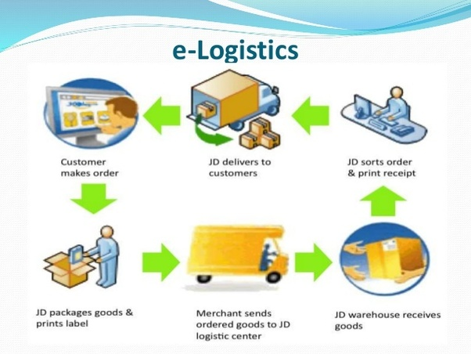

Figure 1:Current system

## Problems of the Existing System

An increase in traffic and inflation have currently been observed yet people need goods and have to move from one place to another. It’s been noticed that due to the increase in traffic and fare cost, people have been spending and wasting time and money every time they want to connect from one place to another. Due to these facts, there has been a decrease in sales as well as cash collection also, the Rwandan population to order products they want online without requiring them to go anywhere.

Lack of timely information on products in markets, transport and trusted delivery services have contributed to some of the issues. The current system or way users go looking for transport and order should be done through the platform I’m developing, and this will address the above-mentioned issues. There is the security and safety of goods in transportation. Current way is limiting the user to order anytime they want and transport their products everywhere in the country.

## Proposed Solutions

Our proposed solution is to provide a system that will help many people whoever wants to order or to sell the building properties or transport it via to this platform what they do with the help of order and advertise well will be able to do so in case they have all that is required of them and go through a clear process saving them unnecessary time wasted.

The proposed solution will be able to link the transportation companies or individuals with clients to access information in real time and receive services from online. This will eventually reduce time needed to accomplish the goal of the needed service. In addition to that, this platform will be able to be used by the people who live abroad as they will be able to order and advertise or buy our properties and safely transport to any place, they wish on the Rwanda market in a transparent manner.

## System Requirements

## Functional Requirements

Functional requirements define the basic system behavior. Essentially, they are what the system does or must not do, and can be thought of in terms of how the system responds to inputs. Functional requirements usually define if/then behaviors and include calculations, data input, and business processes.

* The system should allow users to create an account
* The system should allow us to make an order.
* The system should provide users with visibility on the transport available and cost when ordering a product.
* The system should allow admins to approve registered user through email
* The system should allow admins to manage user based on location
* The system should be able to differentiate an admin from another user and direct them to their corresponding page.
* The system should allow admins to view all products added.
* The system should allow admins to delete, update, and insert products to be added to platform.
* The system should accept a range of inputs from the user
* The system should allow the user to log-in/sign-up using a Google, Facebook, Microsoft, or Apple account.
* The system should be able to check if the log-in details are correct
* The system should allow the user to enter a valid credit card detail.
* The system must be able to determine if a card is valid or not
* The system should allow the owner to edit and delete their posts
* The system should be able to send notifications to a user.
* The system should allow admins able to manage the Transport Company.
* The system should allow admins to manage orders.
* The system should allow admins to view report
* The system should allow admins to accept or reject added products to publish so that it can go to the public.
* The system should allow admins to confirm that a product arrives to the corresponding client of that product.
* The system should allow transport users to accept the order.
* The system should allow transport users to update the status of the order.

## Non-Functional Requirements

Nonfunctional requirements are the requirements that specify the criteria that can be used to judge the operation of a new system, rather than specific behaviors. Non-functional requirements serve as constraints or restrictions or policies on the system. Non-functional requirements describe how the system should work and in which conditions the system should be allowed to work. It defines system attributes such as security, reliability, performance, maintainability, scalability, and usability.

Below are the non-functional requirements of Standardized Ordering and Transport Planning Practice System:

* The system must encrypt the user's password.
* The system should provide the right privileges according to user type.
* The user has to login to perform a certain action.
* The system must perform user request within 10 sec
* The system should not exceed 20 secs in case of downtime
* The user request will not exceed 2 clicks to be completed.
* The system must calculate total purchase and sales within 10 sec
* The system should be accessible on laptops/tablets/mobile phones.
* The system should be accessed within local network infrastructures web based
* The system should be online for whoever needs it.
* The system must be easy to use and learn from different users.
* The system must handle up to 500 simultaneous users.
* The system must respond to most inputs within 2 seconds.
* The system must respond to complex requests within 20 seconds.
* The system must be available at all times.
* The system must be able to cope with expansions to global availability.
* The system must be able to add support for different languages.
* The system must operate in accordance with Rwanda’s laws.

# CHAPTER 3

# REQUIREMENTS ANALYSIS AND DESIGN OF THE NEW SYSTEM

## Introduction

Systems are created to solve problems. One can think of the systems approach as an organized way of dealing with a problem. In this dynamic world, the subject System Analysis and Design, mainly deals with the software development activities. The development of a system requires time, effort, and attention. The strongest purpose for building a new system is to fulfill the needs of its users and solve all the problems they face while using the existing system. Strong analysis of a user’s needs will most of the time lead to useful software development, as a system might give a perfect result.

System development is generally composed of two main components:

* **System Analysis**: This is a process of collecting and interpreting facts, identifying the problems, and decomposing a system into components. *System analysis* is conducted for the purpose of studying a system or its parts in order to identify its objectives. System analysis consists of collecting, organizing, and evaluating facts about a system and the environment in which it operates. The objective of system analysis is to examine all aspects of the system and to establish a basis for designing and implementing a better system. It is a problem-solving technique that improves the system and ensures that all the components of the system work efficiently to accomplish its purpose. An analysis specifies what the system should do.
* **System Design**: This is a process of planning a new business system or replacing an existing system by defining its components or modules to satisfy the specific requirements. Before you plan, you need to understand the old system thoroughly and determine how computers can best be used to operate efficiently. The design phase comes after a good understanding of the customer’s requirements; this phase defines the elements of a system, the components, the security level, modules, the architecture, and the system has different interfaces and types of data that go through it. With this system development phase,

The developer and the user develop a concrete understanding of how the new system will operate. System design focuses on how to accomplish the objective of the system. A good system design is impossible without careful and accurate system analysis. The two components (system analysis and system design) are mostly effective because the design of an information system would not be effective if the developer did not reflect on the entire organization that must be implemented (Dennis, 2015).

System Design focuses on how to accomplish the objective of the system.

## Unified Modeling Language (UML)

The Unified Modeling Language (UML) is a general-purpose, developmental modeling language in the field of software engineering that aims to provide a common approach to depict system architecture. The language provides notations for creating models and is expressly meant to be implemented by CASE tools.

Naturally, the pieces that make up a UML model imply some features of technique, but UML is only a visual syntax for building models. It provides no modeling methods (Nishadha, 2021).

A **model** a thing used as an example to follow or imitate. It is easier to refer on a model than to refer on the reality because the model represents just essential aspects of the reality and ignores the useless aspects. The UML provides many different models for a system such as use case diagram, class diagram, sequence diagram.

It is not required to make all the models for a system; instead, it is advised to model the ones that are to visualize sufficiently the system.

## Design of the New System

System design is the first phase of the system development life cycle in which you and the user develop a concrete understanding of how the system will operate.

Systems design is the process of defining the architecture, components, modules, interfaces, and data for a system to satisfy specified requirements.

## Use-Case Diagram

Use case diagram is UML diagram which shows some business or software system, its external users (called [actors](http://www.uml-diagrams.org/use-case-actor.html)), and a set of actions (called [use cases](http://www.uml-diagrams.org/use-case.html)) that users of the system should or can perform while using the system. Use case diagrams are used to describe functionality of a system from the point of view of external users (Jeffrey L, 2007).

Use case diagrams consist of actors, use cases and their relationships. The diagram is used to model the system/subsystem of an application. A single use case diagram captures a particular functionality of a system.

Use case diagrams are used to gather the requirements of a system including internal and external influences. These requirements are mostly design requirements. Hence, when a system is analyzed to gather its functionalities, use cases are prepared and actors are identified.

The symbols below are used in use case diagram:

|  |  |
| --- | --- |
| Description | Shape |
| An actor:   * Is a Person or system that derives benefit from and is external to the subject? * Is depicted as either a stick figure (default) or if a nonhuman Acton is involved, as a rectangle with « actor » in it (alternative). * Can be associated with other actors using a specialization/super class Field, denoted by an Arrow with a hollow arrowhead. |  |
| A use case:   * Represents a major piece of system functionality. * Can extend another use case. * Can include another use case. * Is placed inside the system boundary. * Is labelled with a descriptive verb–noun phrase. |  |
| A boundary:   * It is a box drawn around the use case to denote the edge or boundary of the system being modeled. * Includes the name of the subject inside or on top. * Represents the scope of the subject, e.g., a system or an individual business process. |  |
| A Field relationship:   * Links an actor with the use case(s) with which it interacts. |  |

Table 1:Use case Diagram element

The figure below describes the operations of new system and the stakeholders through the use case diagram.

**Use Case Diagram**

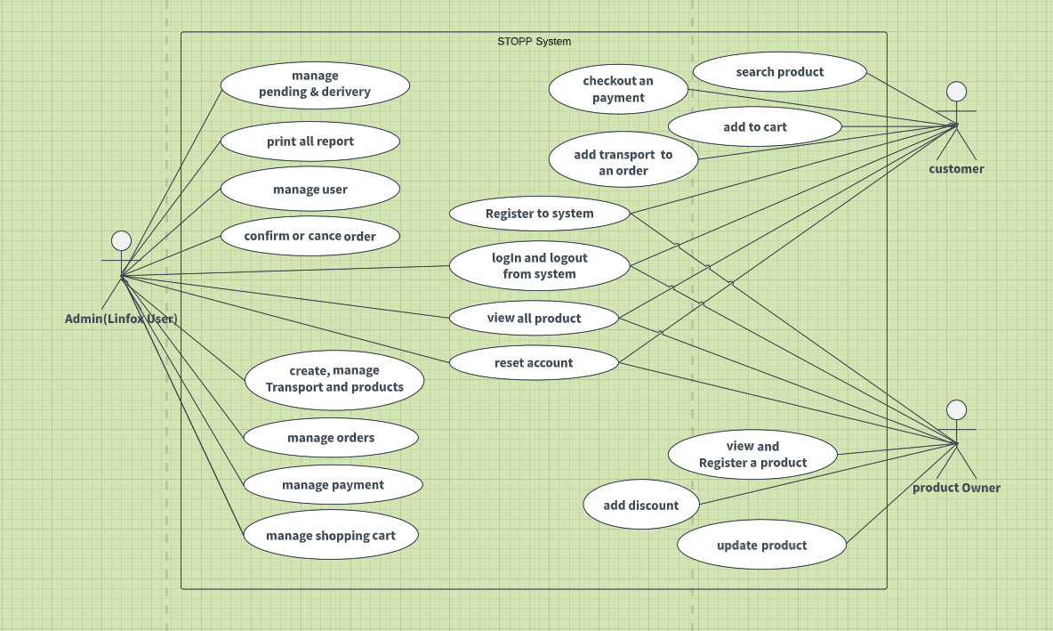

Figure 2:Use Case Diagram

### Use case description

Use case description details what a use case does, and what it requests in order to be well executed. Each use case looks like this:

**Name:** what a system intends to do Actor: the actor involved in the use case

**Actors:** The actor involved in the use case

**Goals:** goals of user to our system.

**Basic flow**: the actual steps of the use case

**Alternative flow**: steps which may happen in case a normal flow fails.

### *Use case description to Create account*

|  |
| --- |
| **Name:** Create account |
| **Actors: System Admin (Linfox)**, Product Owner, client |
| **Goals:** it allows System Admin (Linfox), a product owner, and a client as well to create an account to the system so that they have access to it. |
| **Basic flows:**   * An actor requests a form for creating an account. * System displays a requested form. * An actor fills out the form depending on the required data. * System stores entered data, and a successful message is displayed. |
| **Alternative flow:**   * If an actor enters incorrect data on the requested form, the system displays an error message. |

Table 2:Create account

### *Use-Case description for Login*

|  |
| --- |
| **Use case name:** login |
| **Actors: System Admin (Linfox)**, Product Owner, client |
| **Goals:** an actor login in order to get full access to the system. |
| **Basic flows:**   * An actor (product Owner, client, or System Admin (Linfox)) requests a form for logging in. * The system displays a requested login form. * An actor fills out the form depending on the required data. * The system checks the entered data and compares them to the ones in the database. * After verifying the entered data, a login successful message is displayed. * An actor gets full access to the system. |
| **Alternative flow:**   * If an actor enters the incorrect data on a requested form, the system displays an error message, and the current page is displayed again. |

Table 3:Login

### *Use case description to record a product*

|  |
| --- |
| **Use case name:** register a product |
| **Actor:** product owner |
| **Goals:** the main goal of registering a product is to keep their data and let clients know about it and its services. |
| **Basic flows:**   * A product owner requests a login form to the system * A system displays the requested login form * A product owner enters the required data. * A system authenticates Product Owner’s entered data. * A system displays a login successfully message. * A product owner requests a product registration page for the system. * A system displays a requested registered Product page. * A product owner enters the required data to register a Product. * A system checks if the entered data are valid. * A system displays a recorded successful message. |
| **Alternative flow:**   * If a product owner enters the wrong data while logging in, an error message occurs and displays a login form again until the product owner enters the valid and right data. * If a Product Owner enters wrong data while recording a Product, a system displays an error message, and the current page appears until valid data is entered. |

Table 4:Record a product

### *Use case description to Client Order Product*

|  |
| --- |
| **Use case name:** make Order |
| **Actor:** client |
| **Goals:** the main purpose of making an order for a given product so that client can get the product he/she wants at the time. |
| **Basic flows:**   * A client requests a login form to the system. * A system displays the requested login form. * A client enters the required data. * A system authenticates the client’s entered data. * A system displays a login successfully message. * A client requests a Product to add to the cart after making his or her order he/she has to look for transport if they require it to the system. * A system displays a requested product that is in the cart so that it can be checked out. * A system checks if the transport and product is available. * A system displays an ordered product successfully created message. |
| **Alternative flow:**   * If a client enters the wrong data while logging in, an error message occurs and displays a login form again until the client enters the valid and right data. * If the ordered product and transport are wrong, the system displays an error message, and the current page appears until a valid order is made. |

Table 5:Client Order Product

### *Use case description to make a payment for a particular order and transport*

|  |
| --- |
| **Use case name:** make a payment |
| **Actor:** client |
| **Goals:** the main purpose of making payment, is to validate your reservation. |
| **Basic flows:**   * A client requests a login form to the system. * A system displays the requested login form. * A client enters the required data. * A system authenticates the client’s entered data. * A system displays a login successfully message. * A client requests an ordered and transport payment page to the system. * A system displays a requested order and transport payment page. * A client enters the required data for making a payment and chooses a method to use. * A system checks if the entered data are valid. * A client prints a payment invoice. * A system displays a successful payment message. * A system sends a payment invoice to your email address. |
| **Alternative flow:**   * If a client enters wrong data while logging in, an error message occurs and displays a login form again until a client enters the valid and right data. * If a client enters wrong data while making a payment, a system displays an error message, and the current page appears until valid data are entered. |

Table 6:Payment for a particular order and transport

### *Use case description to change Order status*

|  |
| --- |
| **Use case name:** change Admin (Linfox) status |
| **Actor:** System Admin |
| **Goals:** the main goal of changing order status is to solve problems raised by clients in a certain product*.* |
| **Basic flows:**   * A client requests a login form to the system. * A system displays the requested login form. * A client enters the required data. * A system authenticates the client’s entered data. * A system displays login successfully message. * An admin views all the order that have been reported by clients. * An admin changes the status of any order that has been reported. * A system displays an updated successful message. |
| **Alternative flow:**   * If a client enters wrong data while logging in, an error message occurs and displays a login form again until a client enters the valid and right data. |

Table 7:change Order status

## Class Diagrams

A class diagram is a static structural diagram that shows the system's classes, properties, actions (or methods), and connections among objects. A class diagram depicts a collection of classes, interfaces, and collaborations, as well as their connections; it addresses a system's static design perspective (Fonseca, 2020).

**Benefits of class diagrams**

Class diagrams offer several benefits for any organization. Use UML class diagrams to:

* Illustrate data models for information systems, no matter how simple or complex.
* Better understand the general overview of the schematics of an application.
* Visually express any specific needs of a system and disseminate that information throughout the business.
* Create detailed charts that highlight any specific code needed to be programmed and implemented to the described structure.

Provide an implementation-independent description of types used in a system that are later passed between its components. (Ayala, 2017)

**SCHEMA OF CLASS DIAGRAM**

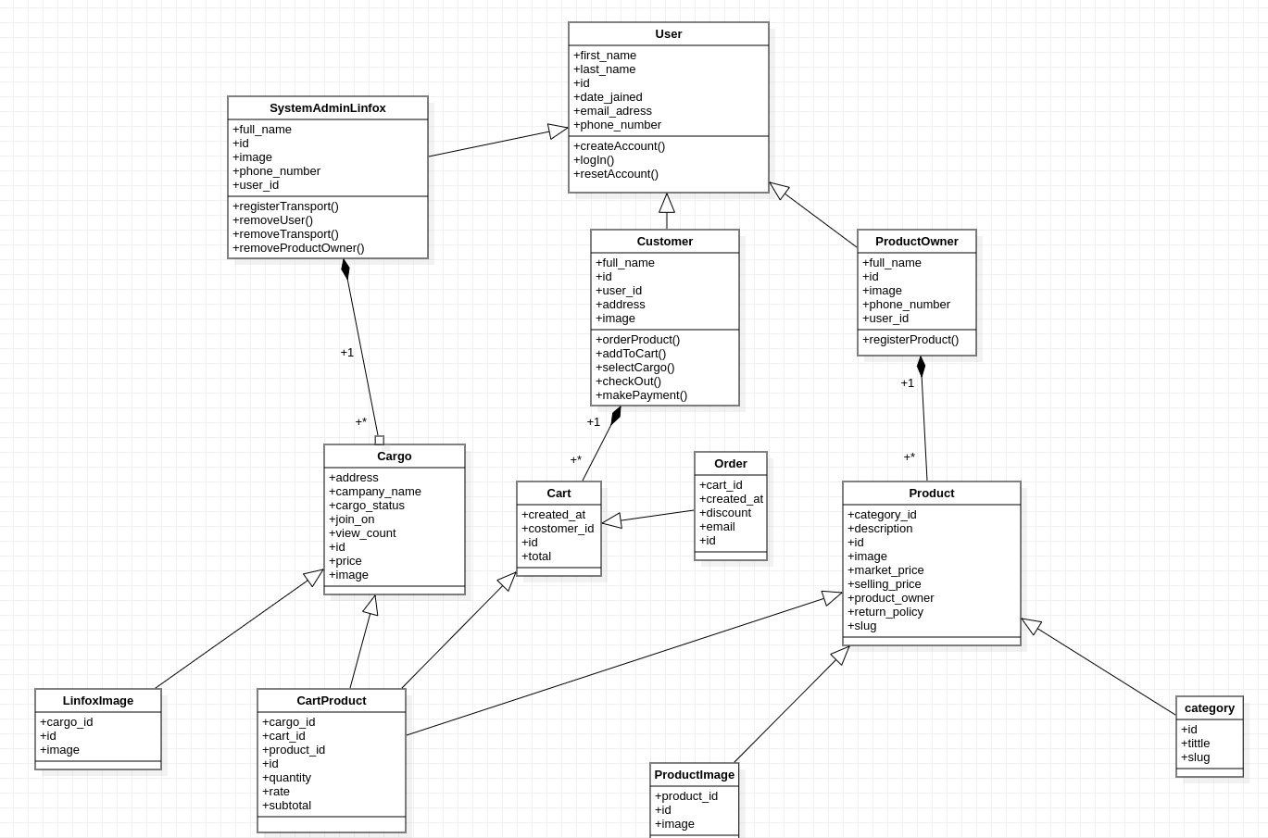

Figure 3: System's Class diagram

## Sequence Diagram

Sequence diagrams describe interactions among classes in terms of an exchange of messages over time. They're also called event diagrams. A sequence diagram is a good way to visualize and validate various runtime scenarios. These can help to predict how a system will behave and to discover responsibilities a class may need to have in the process of modeling a new system. (Croft, 2016)

The notations and their definitions that are used in sequence diagram:

|  |  |  |  |
| --- | --- | --- | --- |
| **Term and definition** | **Symbol** | | |
| **An actor:**   * It can be a person or system that derives benefit from and is external to the system. * It participates in a sequence by sending and/or receiving messages. * It is placed across the top of the diagram. | |  |  | | --- | --- | | **Actor lifetime** | | |  |  | | | |
| **An object:**   * It participates in a sequence by sending and/or receiving messages. * It is placed across the top of the diagram. | |  |  | | --- | --- | | **object lifetime** | | |  |  | | | |
| **An activation**:   * Is a lifeline a long, thin rectangle on top? * It indicates whether an item is transmitting or receiving messages. |  |  |  |
| **A message**:   * It is used to transfer data from one item to another. * An operation call is shown by a solid arrow and the message being sent, whereas a return is indicated by a dashed arrow and the value being returned. |  | | |

Table 8:Symbols used in sequence diagram

**Sequence diagram for creating a layer of the organization structure**

As the sequence diagram graphically displays the interaction between actors and the system, the diagram below clearly describes how the user interacts with the system.

### Create Account sequence diagram

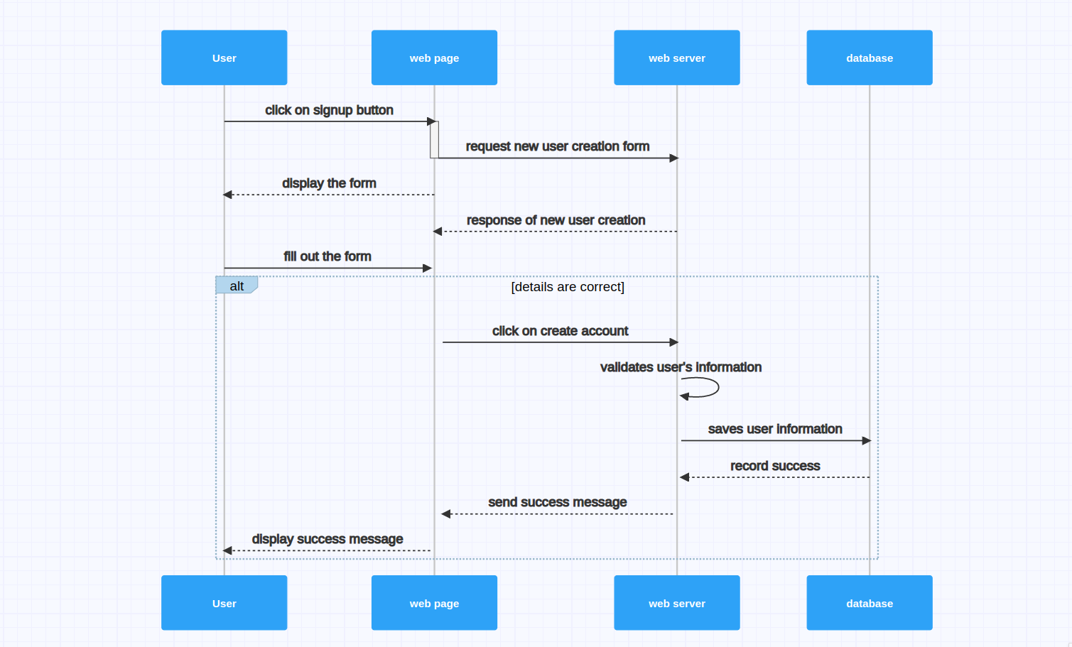

Figure 4:Create account sequence diagram

### Login sequence diagram

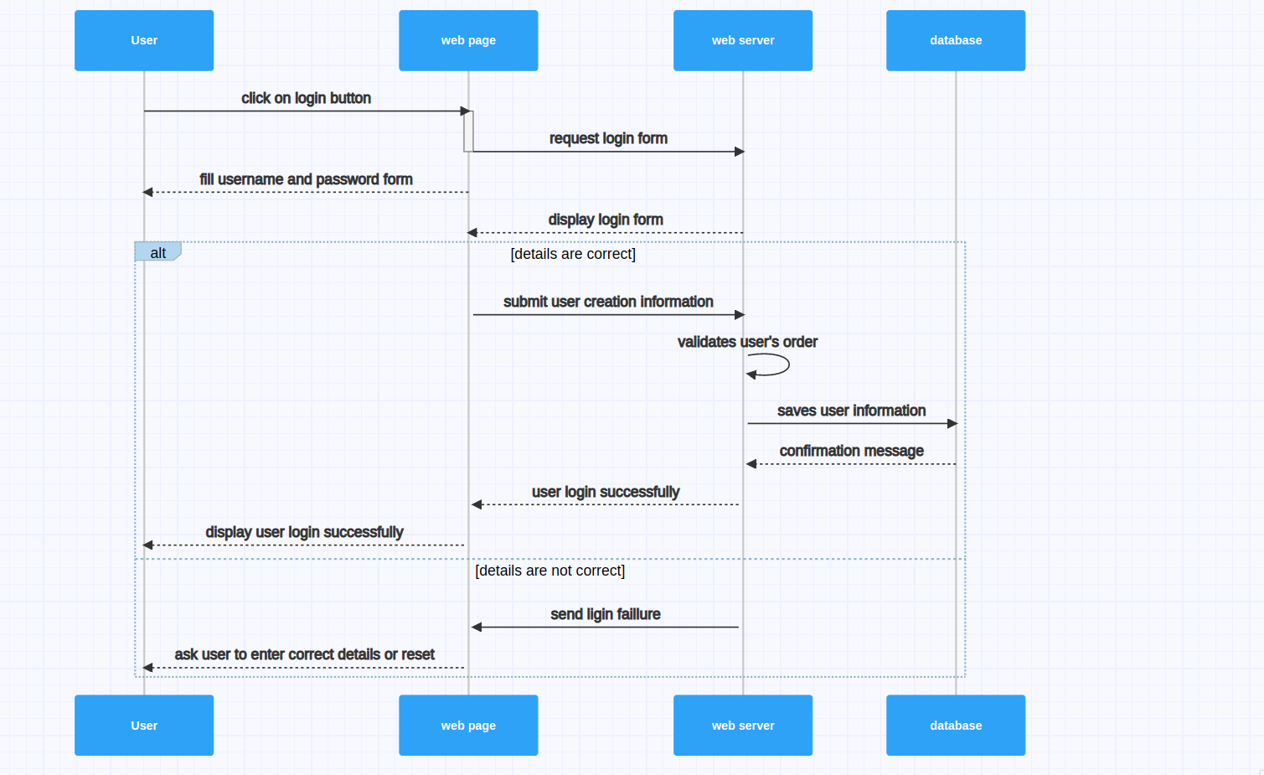

Figure 5:Login sequence diagram

### Place Order sequence diagram

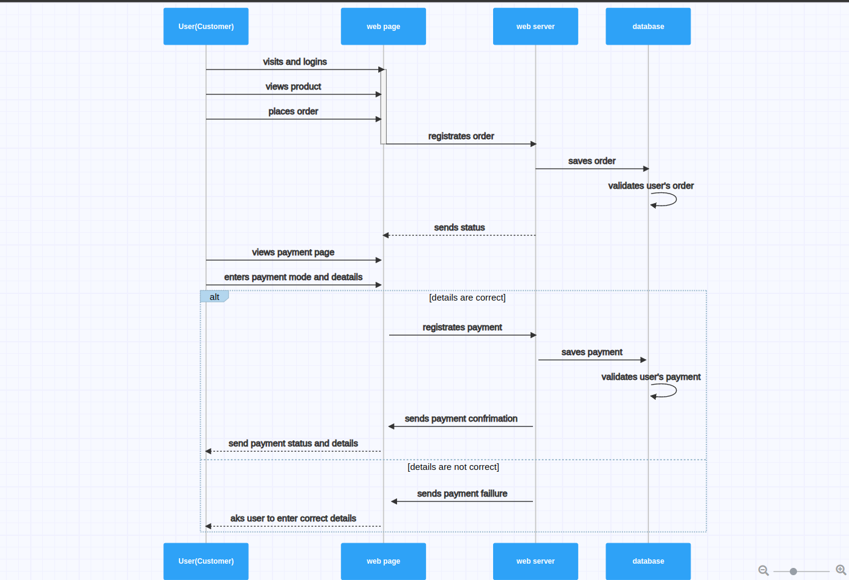

Figure 6:Place order sequence diagram

### Product Owner Publish product sequence diagram

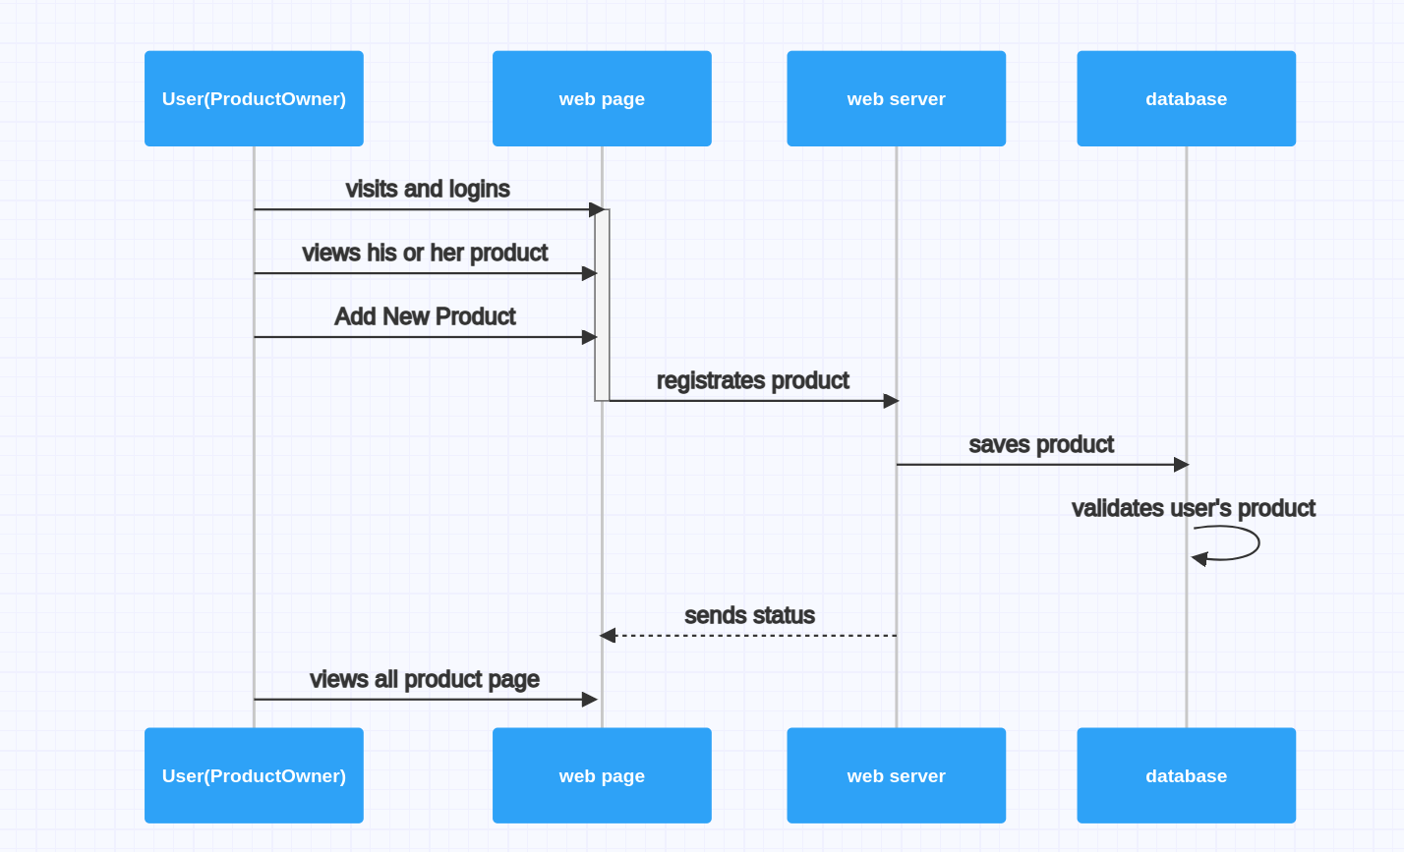

Figure 7:Product Owner Publish product sequence diagram

### Admin (Linfox) register cargo sequence diagram

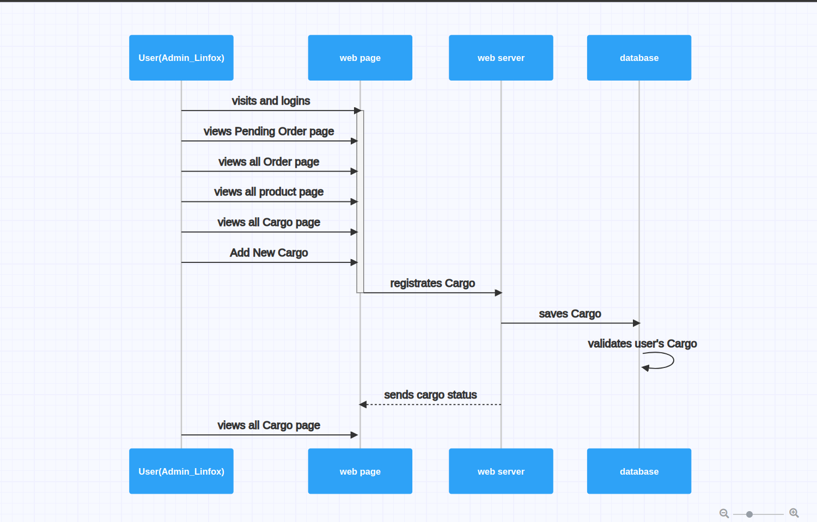

Figure 8:Admin (Linfox) register cargo sequence diagram

## Activity Diagram

An activity diagram visually presents a series of actions or flow of control in a system similar to a flowchart or a data flow diagram. Activity diagrams are often used in business process modeling. They can also describe the steps in a use case diagram. Activities modeled can be sequential and concurrent. In both cases an activity diagram will have a beginning (an initial state) and an end (a final state). (Tate, 2018)



A task is a discrete action that is part of the process.

Exclusive gate ways (decisions) are points in a business process when the sequence can follow one of two or more different courses.

The start (split) and finish (join) of concurrent actions are represented by bars.

The start event specifies the start location for a certain process.

The End event specifies when a process will come to an end.

A sequence flow depicts the order in which actions in a process will be completed.

Flowcharts may be thought of as activity diagrams. Concurrency cannot be expressed using traditional flowchart approaches. However, the join and split symbols in activity diagrams only fix this for basic scenarios; when they are arbitrarily mixed with choices or loops, the model's meaning is unclear.

### 

### Customer Order

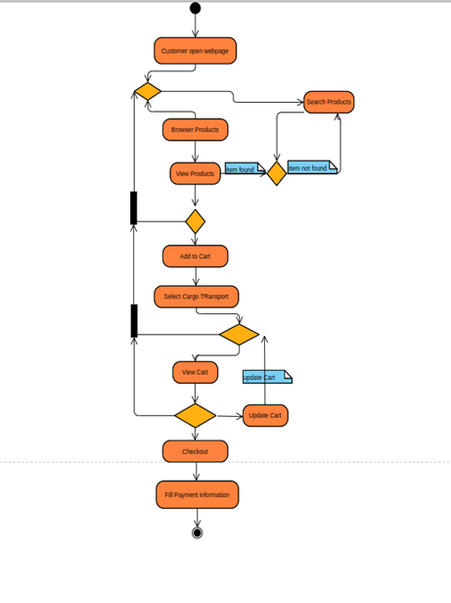

Figure 9: Customer Order

## Database Diagram

Database design is a collection of processes that facilitate the designing, development, implementation, and maintenance of enterprise data management systems. Properly designed databases are easy to maintain, improve data consistency, and are cost effective in terms of disk storage space. The database designer decides how the data elements correlate and what data must be stored.

The main objectives of database design are to produce logical and physical design models of the proposed database system. The term "database design" can be used to describe many different parts of the design of an overall database system. Principally, and most correctly, it can be thought of as the logical design of the base data structures used to store the data. In the relational model, these are the tables and views. In an object database, the Entities and relationships map directly to object classes and named relationships. However, the term "database design" could also be used to apply to the overall process of designing, not just the base data structures but also the forms and queries used as part of the overall database application within the database management system.

A database schema diagram

A database schema is the skeleton structure that represents the logical view of the entire database. It defines how the data is organized and how the relationships among them are associated. It formulates all the constraints that are to be applied to the data. A database schema defines its entities and the relationships among them. It contains scriptive details of the database, which can be depicted by means of schema diagrams. It’s the database designers who design the schema to help programmers understand the database and make it useful.

**DATABASE SCHEMA DIAGRAM**

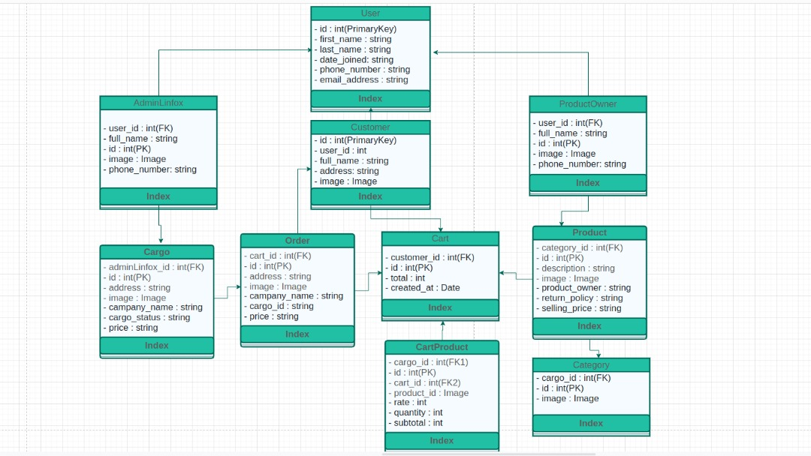

Figure 10:Database schema

## System Architecture Design

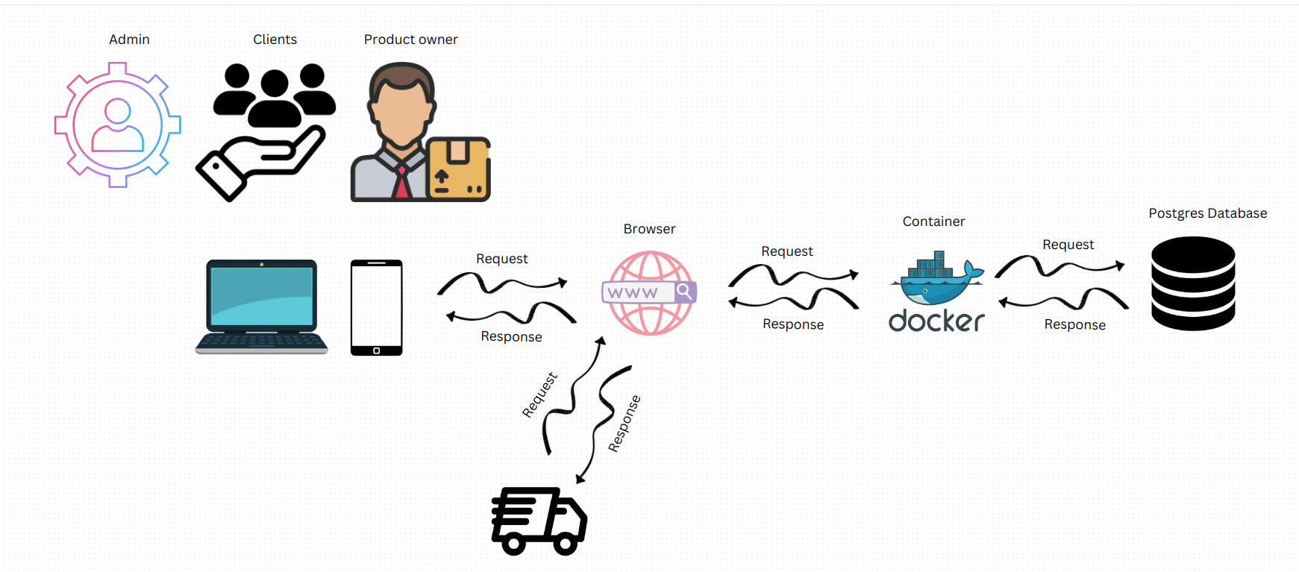A system architecture, also known as systems architecture, is a conceptual model that outlines a system's structure, behavior, and many viewpoints. A formal description and representation of a system arranged in a way that facilitates reasoning about the system's structures and behaviors is known as an architectural description.

Figure 11:System architecture

Our system architecture can be deeply explained by the MVC model (model view controller). Model view controller (MVC) is a very useful and popular design pattern. Since we’re software developers, we should know it. Fortunately, it’s also one of the simplest to truly understand.

# CHAPTER 4

# IMPLEMENTATION OF THE NEW SYSTEM

## Introduction

This chapter describes the development of Standardized Ordering and Transport Planning Practice System. It includes a brief explanation of the technology utilized to create this application, as well as the operations that were used. Finally, software and hardware compatibility requirements.

## Browser compatibility

|  |
| --- |
| **Supported Browsers (Minimum Requirement)** |
| Google Chrome Version 84.0.4147.105 (Official Build) (64-bit) |
| Mozilla Firefox Version 79.0(64-bit |

Table 9:Browser compatibility

## Tools and Technology Used

To develop this application, I have used the following technologies:

|  |  |
| --- | --- |
| **Technology Stack Software** | **product** |
| Integrated development environment | VS Code Editor |
| Database design | StarUML |
| Programming languages | Python (DJANGO), JavaScript |
| Database Server | PostgreSQL, PgAdmin 4 and SQLite3 |
| Web server | Django web server (WSGI) |
| Styling | HTML, CSS, Materialize CSS, Bootstrap. |

Table 10:Tools and Technology Used

**PostgreSQL**: it is a powerful, open-source object-relational database system. It has more than 15 years of active development and a proven architecture that has earned it a strong reputation for reliability, data integrity, and correctness. The purpose of the PostgreSQL database is to store and retrieve related information.

**PgAdmin 4**: it is a management tool for PostgreSQL and derivative relational databases such as Enterprise DB’s EDB Advanced Server. It may be run either as a web or desktop application. PgAdmin is designed to meet the needs of both novice and experienced PostgreSQL users alike, providing a powerful graphical interface that simplifies the creation, maintenance, and use of database objects.

**Visual Studio Code 5:** also commonly referred to as VS Code, is a source-code editor made by Microsoft for Windows, Linux, and macOS. Features include support for debugging, syntax highlighting, intelligent code completion, snippets, code refactoring, and embedded Git.

**HTML:** HTML stands for Hyper Text Markup Language, which is the most widely used language on the Web to develop web pages. It describes the structure of web pages. As I have described its role, I have used HTML to design the web pages for my project.

**JavaScript:** It is a dynamic computer programming language. It is lightweight and most used as a part of web pages, whose implementations allow client-side scripts to interact with the user and create dynamic pages. It is an interpreted programming language with object-oriented capabilities. JavaScript was originally developed by Netscape as a means to add dynamic and interactive elements to websites. This means JavaScript functions can run after a web page has loaded without communicating with the server.

**CSS:** CSS stands for Cascading Style Sheets and is used to format the layout of web pages. In my project, cascading style sheets were used to format the layout of Web pages and to define text styles, table sizes, and other aspects of web pages that previously could only be defined in the page’s HTML. CSS makes it easy to change styles across several pages at once. Internal style sheets are written inside HTML files, and external style sheets are stored in CSS files. CSS saves a lot of work since it can control the layout of multiple web pages all at once.

**Python:** python is a general-purpose interpreted, interactive, object-oriented, and high-level programming language. It was created by Guido van Rossum in 1985-1990. Python is designed to be highly readable. It uses English keywords frequently, whereas other languages use punctuation, and it has fewer syntactic constructions than other languages.

Python is processed at runtime by the interpreter. You do not need to compile your program before executing it (interpreting). It is also interactive, such that you can actually sit at a Python prompt and interact with the interpreter directly to write your programs. Python supports an object-oriented style or technique of programming that encapsulates code within objects. As I have mentioned above, I have used Python as a key programming language.

**Django:** Django is a python-based free and open-source web framework that follows the model-view- controller (MVC) architectural pattern. Django’s primary goal is to ease the creation of complex, database-driven websites. The framework emphasizes re-usability and pluggability of components, less code, low coupling, rapid development, and the principle of don’t repeat yourself. Python is used throughout, even for setting files and data models. Django also provides an optional administrative create, read, update, and delete interface that is generated dynamically through introspection and configured via admin models.

## Presentation of the New System

**My home pages.**

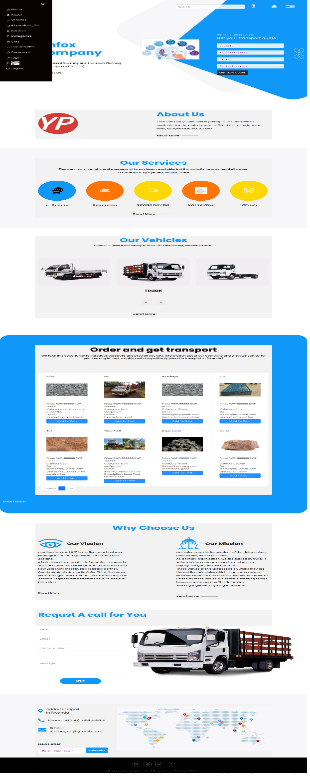

Figure 12: My home page

### Login as admin

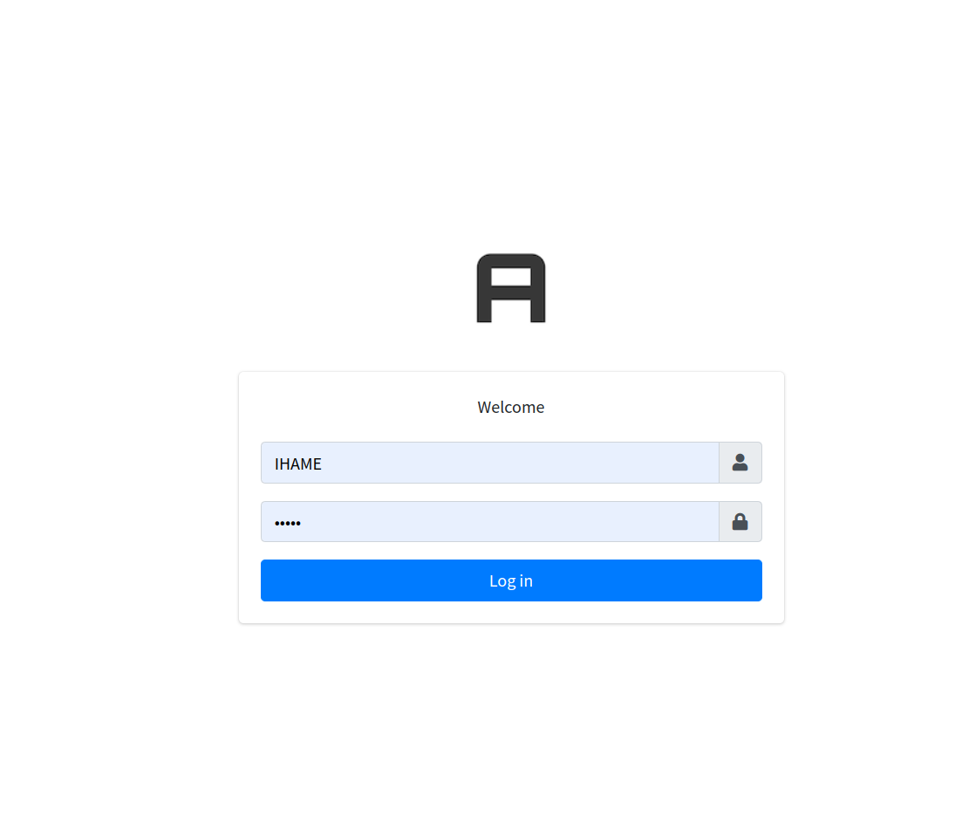

Figure 13: Log in as admin

### Admin Home page

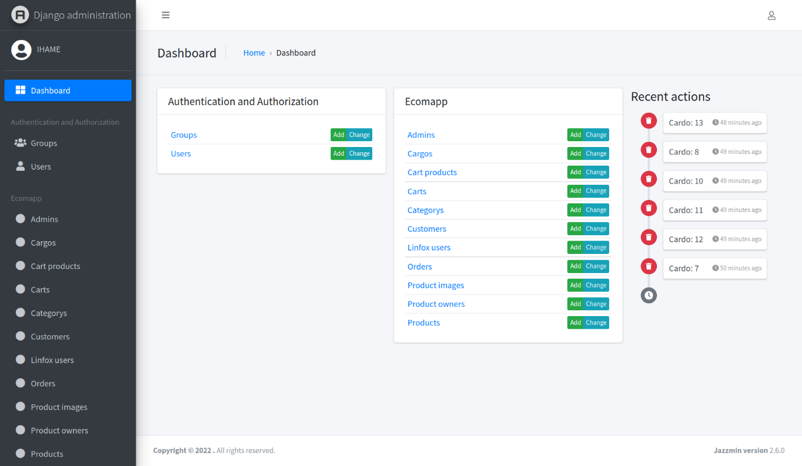

Figure 14:Admin home page

Admin change status completely

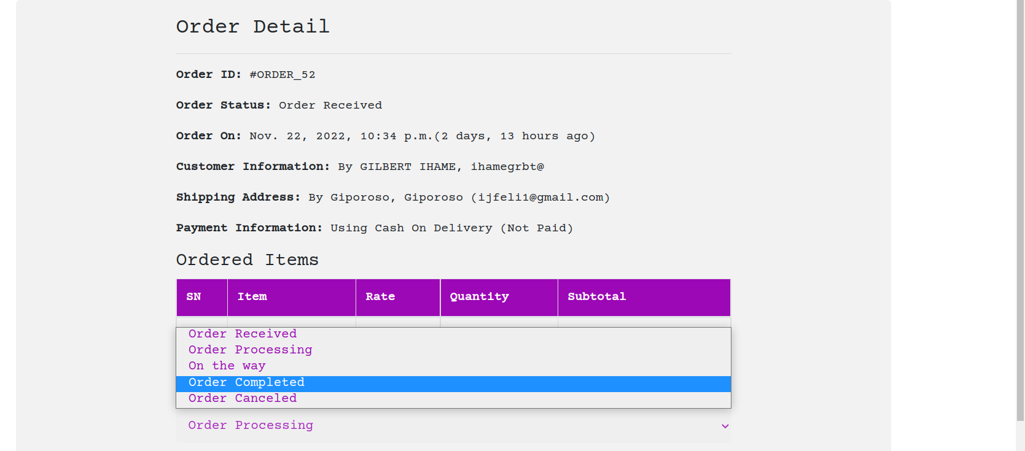

Figure 15:Admin change status completely

Admin home

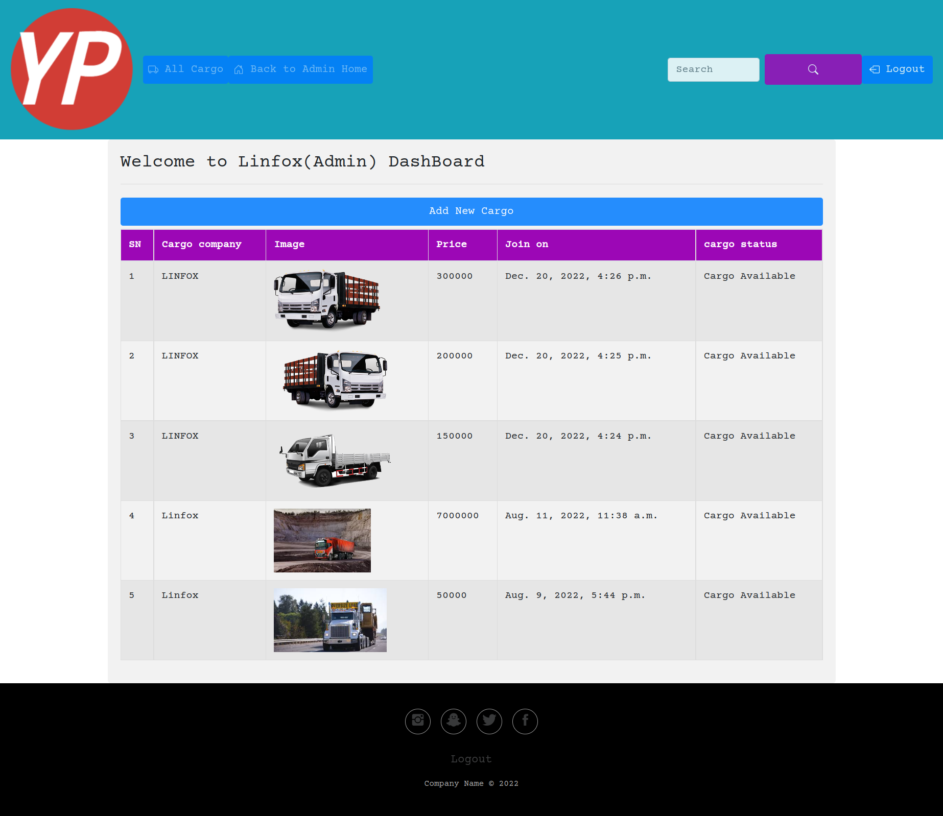

Figure 16:home admin

All users

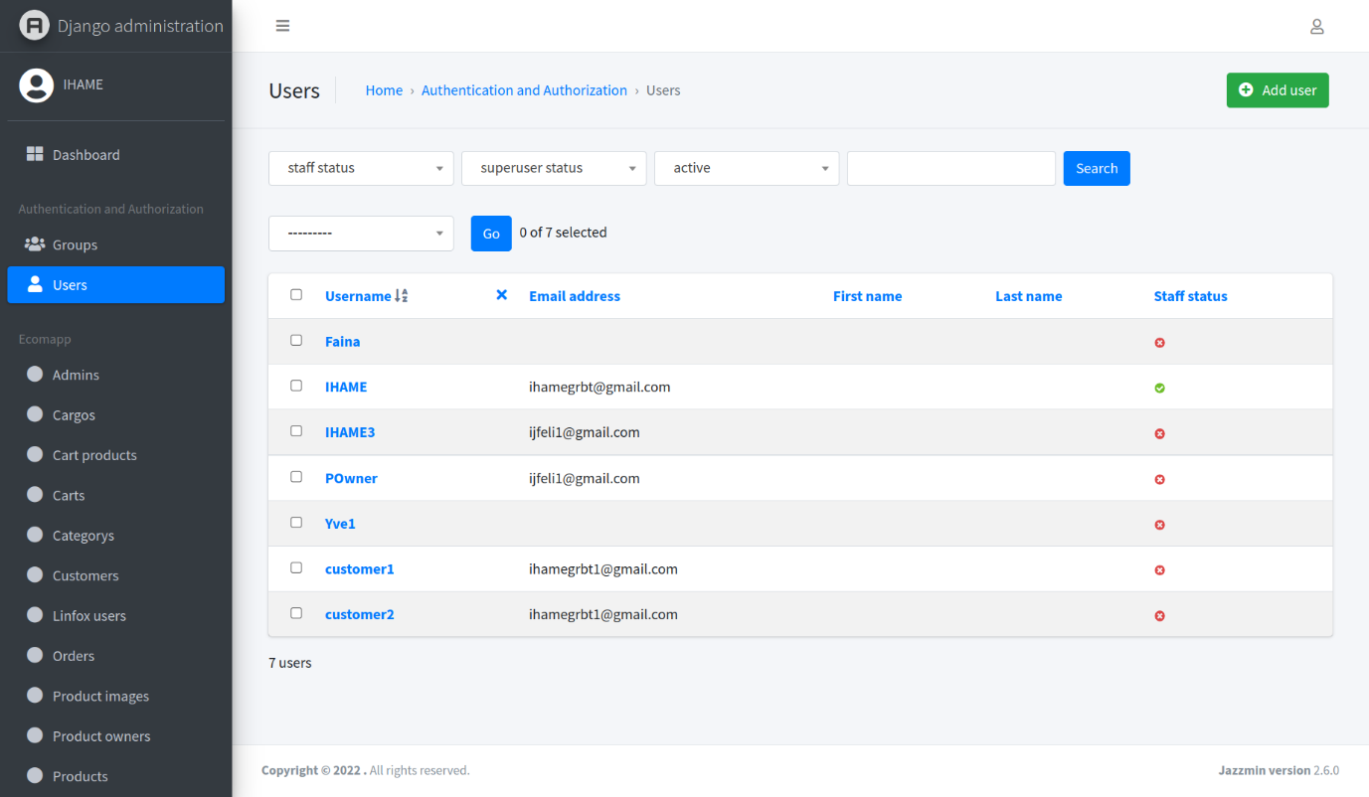

Figure 17: All users

Payment Form

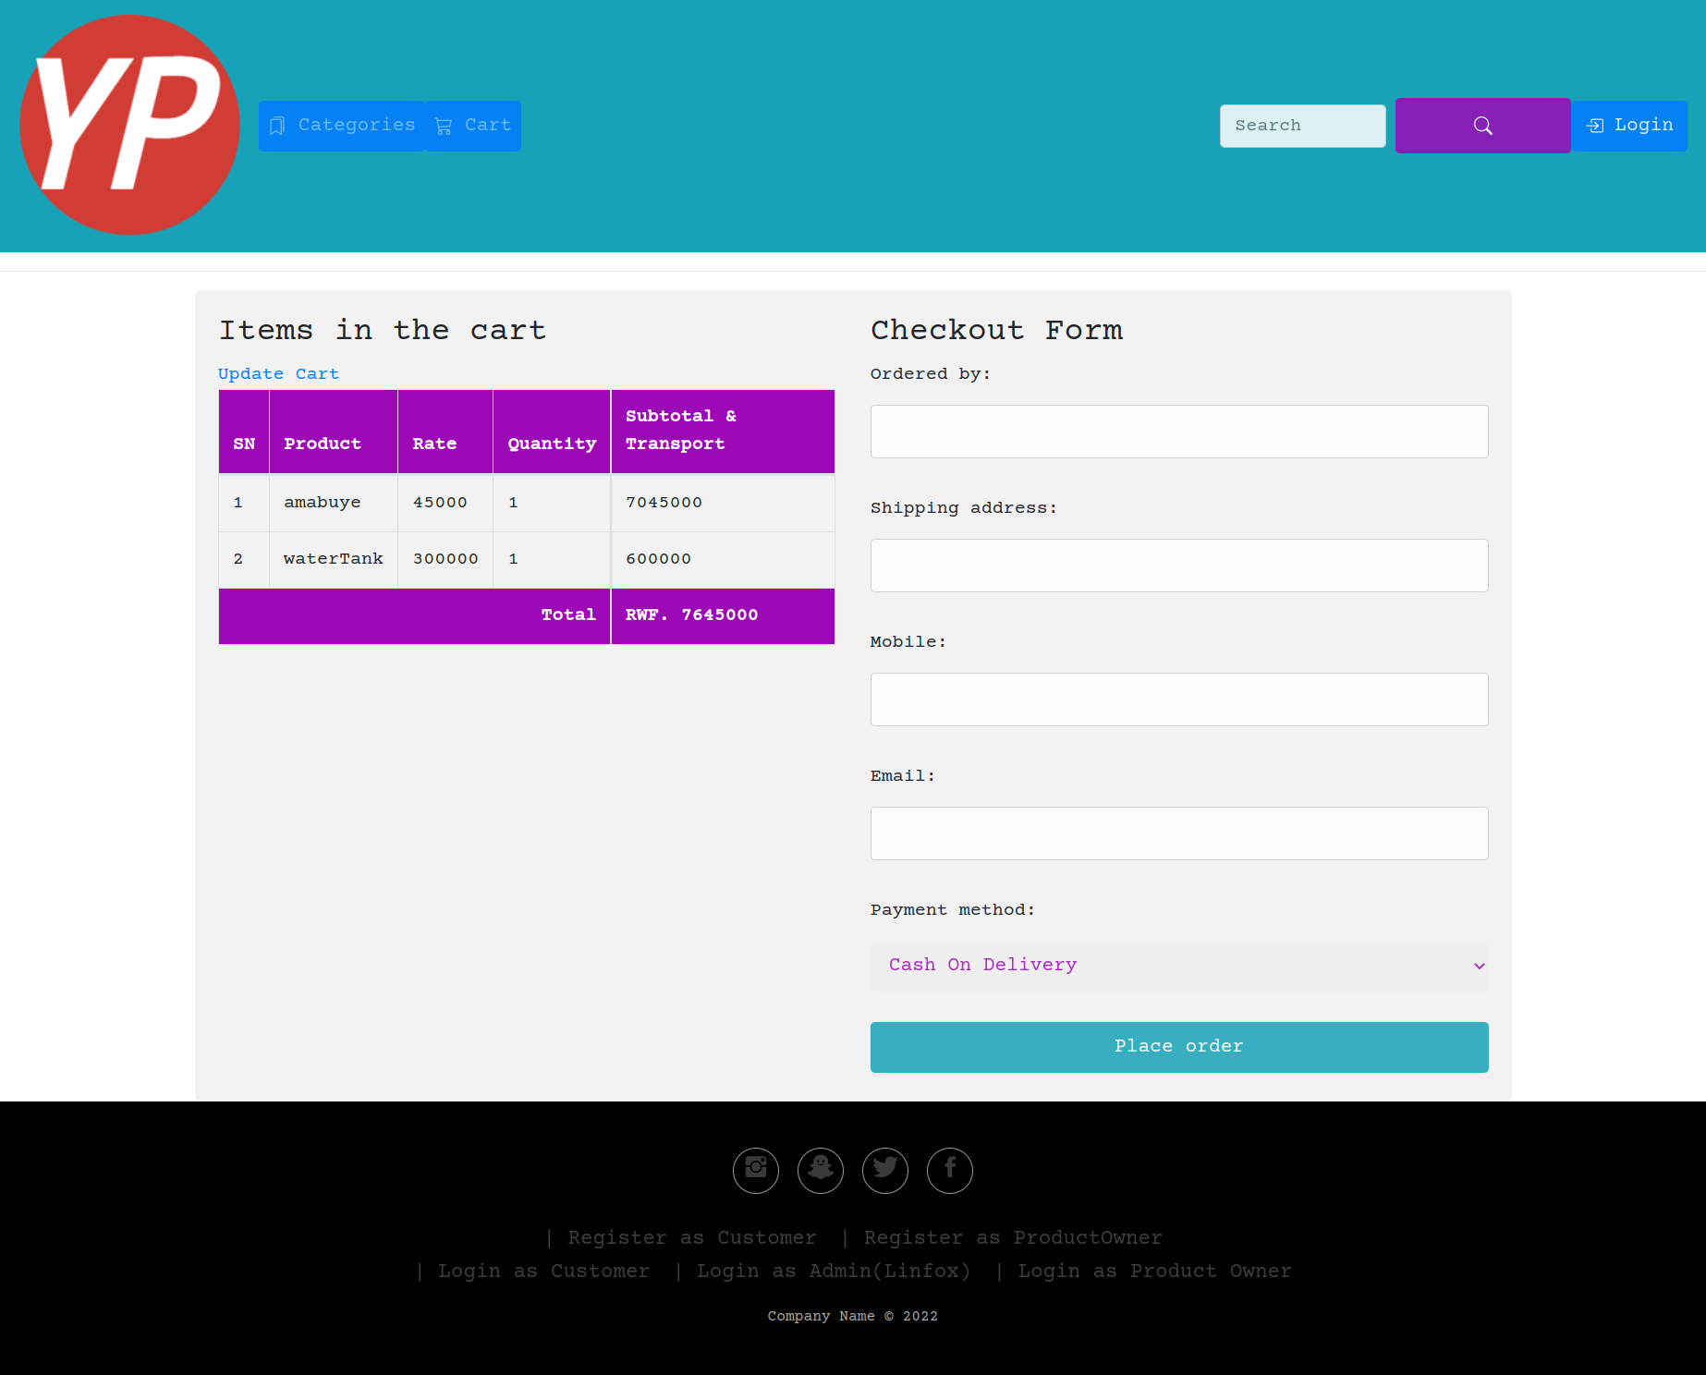

Figure 18:Check out

Profile Log in authorization

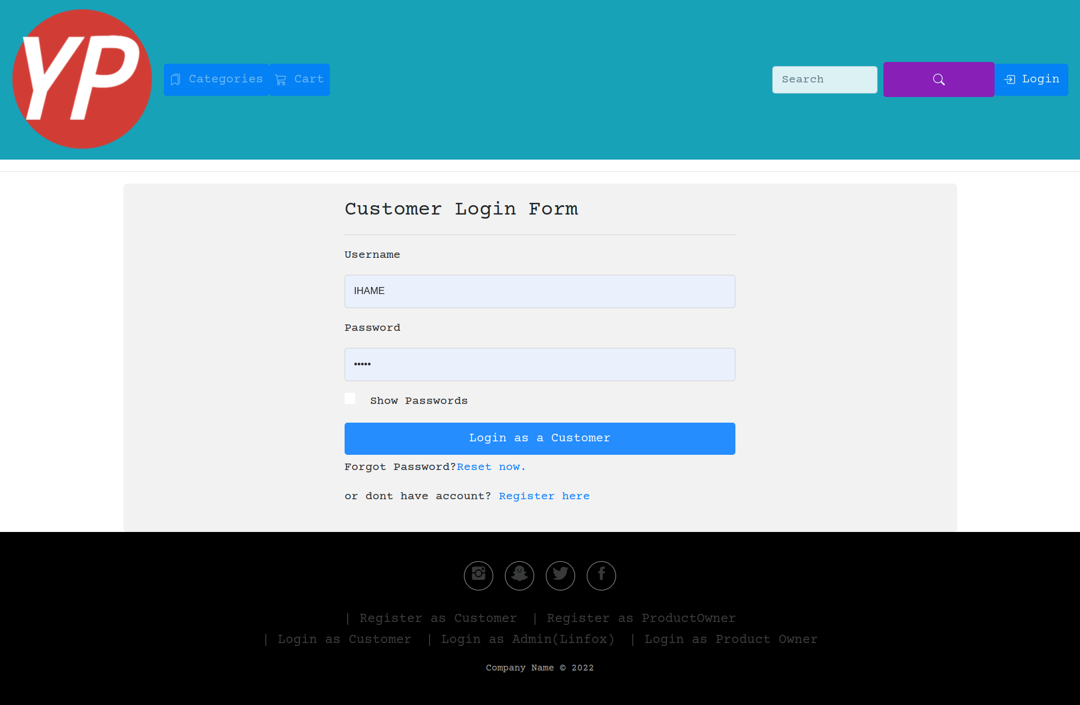

Figure 19: Profile Log in authorization

Product Owner Home

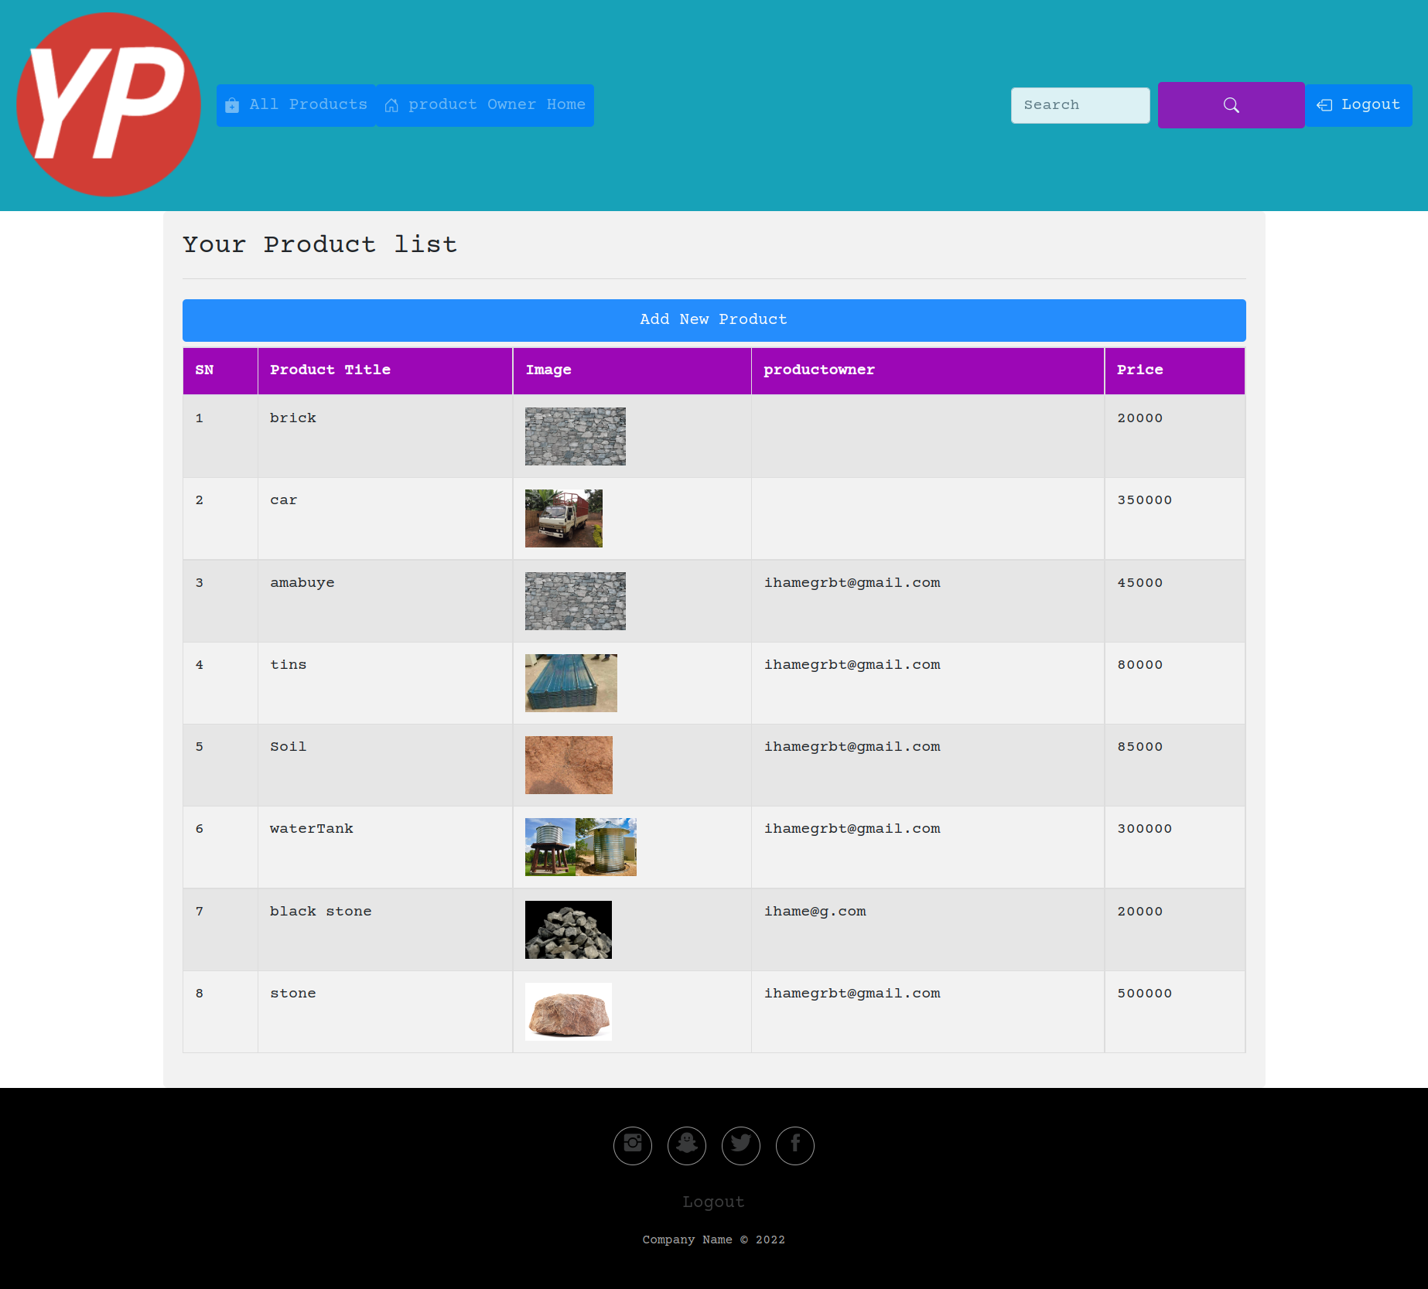Figure 20: Product Owner home

**Product and Cargo**

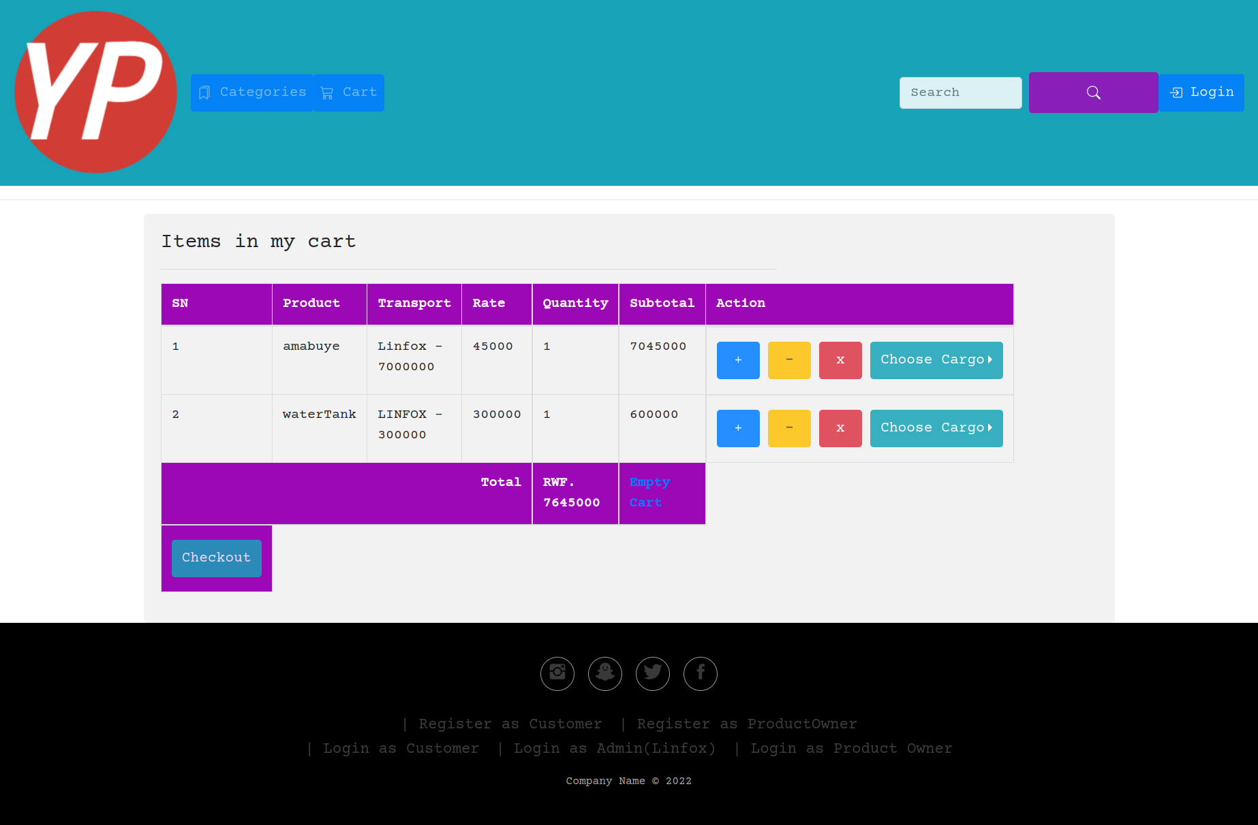

Custom profile

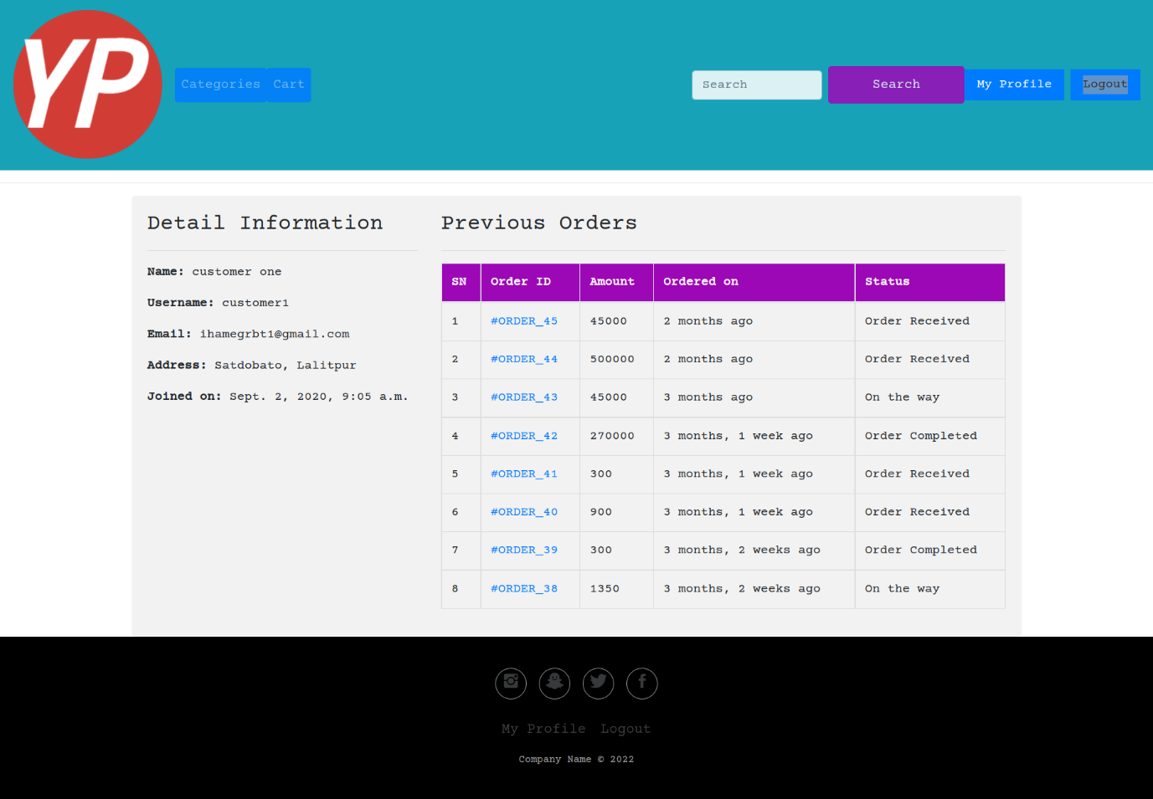

Figure 21: Profile

Adit admin profile

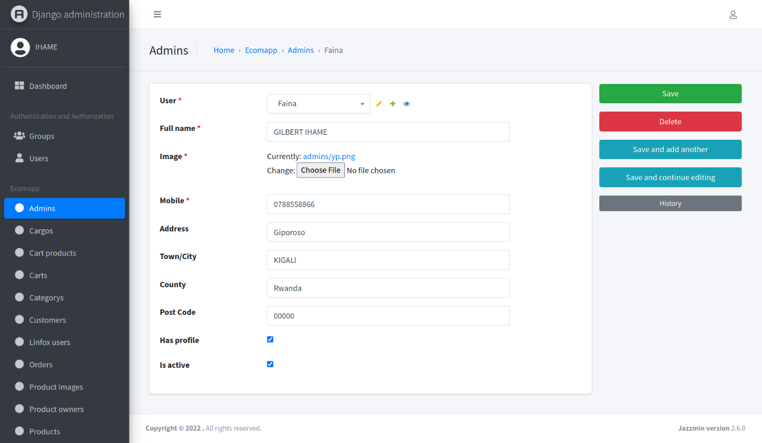

Figure 22: Manager users

## Software Testing

Software tests play an important role in the software designing. They help to verify the effectiveness of the software to see if it actually does what it was supposed to solve.

Listed are key aspects to take into consideration in software testing

* Does the application meet the requirements that guided its design and development?
* Does the application works as expected?
* Can the application be implemented with the same characteristics and satisfies the needs of the users?

The following are some software testing

### The Unit Test

Unit testing is a process to ensure the proper functioning of software or a portion of a program. It is a method by which individual units of source code, sets of one or more computer program modules together with associated control data, usage procedures, and operating procedures, are tested to determine if they are fit for use. In other words, every small component that can be compiled with the goal to know that every unit matches to its specifications, and to know if there are logical mistakes. Indeed, the unit test is

an efficient means that permits to detect the maximum possible mistakes. The application has been checked with the unit test at each piece of the code written.

### The Integration test

is the phase in software testing in which individual software modules are combined and tested as a group. This test is useful to check the assembly of the different part of the software. It is also a progression of tests, in which the software and hardware components are collected and tested until the entire system is tested. The application modules have been successively tested until completion to ensure that the whole constituted by the assembled software components answers to the required functional and technical specifications.

### The Validation test

The last test phase has the role of validating the software in its external environment. The product has been put in final situation in order to verify if it perfectly answers to the needs expressed in the first phase. The validation test is important, since it is necessary to verify if the setting up of the application corresponds to the expressed needs. For example, the national Id should be 16 digits and the email address should contain @ and ends with Gmail, yahoo.com. The application has been tested in its entirety, and it is in this way that we noticed that the progress of operations done corresponds to the functional specifications.

# CHAPTER 5

# CONCLUSION AND RECOMMENDATIONS

## Conclusions

Designing and implementing tools to help Standardized Ordering and Transport Planning Practice System was the primary goal of this project. of the Standardized Ordering in an easy and efficient way and also help people who wants register and access the reports to reach into them as soon as possible at anytime and anywhere. Surely the way application of users was being made until the applicant would get the Transport Planning Practice System that the users was given or not, was not accurate and sufficient as the applicant was supposed to wait without any knowledge of what is happening in that process. Unquestionably, the redesign of the current system required the designing and implementing of the new system.

We believe that the use of this technology and its integration will provide many advantages to Transport Planning Practice System alike. Every user of the system will be able to obtain the specifics of every action that is taken, in addition to Transport Planning Practice System Standardized Ordering receiving complete information about every action. It goes without saying that the system will make every operation quicker, simpler, and more visible.

In concluding, the new as stated in earlier chapters, the tool (system) was successfully implemented and is functioning as intended.

## Recommendations

I would want to recommend that the Standardized Ordering and Transport Planning Practice System that accept domestic Transport Planning Practice follow the new procedure going forward. I'll conclude by requesting that everyone who is interested and researchers consider any additional features that can help improve this work in order to advance this subject in various research endeavors in Rwanda.

# REFERENCES

## Books

Dennis, A., Wixom, B. H., & Tegarden, D. (2015). Systems Analysis and Design: An Object-oriented approach with UML. John Wiley & Sons.

Bennett, S., McRobb, S., & Farmer, R. (2005). Object-oriented systems analysis and design using UML. McGraw Hill Higher Education.

Aurum, A., Jeffery, R., Wohlin, C., & Handzic, M. (Eds) (2013). *Managing software engineering knowledge.* Spring Science & Business Media.

## Websites

Arias, B. (2017, January 11). PostGres. Retrieved from searchoracle.techtarget.com: https://searchoracle.techtarget.com/definition/PostgresL,accessed on date June 06, 2019

Ayala, L. (2017, February 11). Class Diagram. Retrieved from tutorialspoint: https://www.tutorialspoint.com/uml/uml_class_diagram.htm accessed on date August 20, 2019.

Benjamin, A. (2022, May 13). Databases. Retrieved from techopedia: https://www.techopedia.com/definition/1247/table accesses on date 08 21, 2019

Carver, S. (2015, July 02). What is integration testing. Retrieved from techopedia.com: https://www.techopedia.com/definition/7751/integration-testing accessed on date June 19, 2019.

Collins, K. (2021, June 14). Jquery. Retrieved from Wikipedia.org: https://en.wikipedia.org/wiki/JQuery accessed on date June 08, 2019

Croft, D. (2016, April 23). Sequence Diagram. Retrieved from smartdraw: https://www.smartdraw.com/sequence-diagram/ accessed on date August 20, 2019.

tryqa, , S. (2016, Feb 09). What is integration testing. Retrieved from techopedia.com: https://www.techopedia.com/definition/7751/integration-testing accessed on date Feb 9, 2022.

# APPENDICES

**CURRICULUMN VITAE**